***UNIT TESTING***

*THE MODERN MARKETEER*

The app is Unit tested with JUnit testing module for Android Studio (v2.2).

The app has been tested for any discrepancies and errors with the Android Studio default debugger and *Gradle.build properties*.

Each Java class used/developed for the application has been tested by making a Test case class and each method has been tested for and all the modules have PASSED the tests.

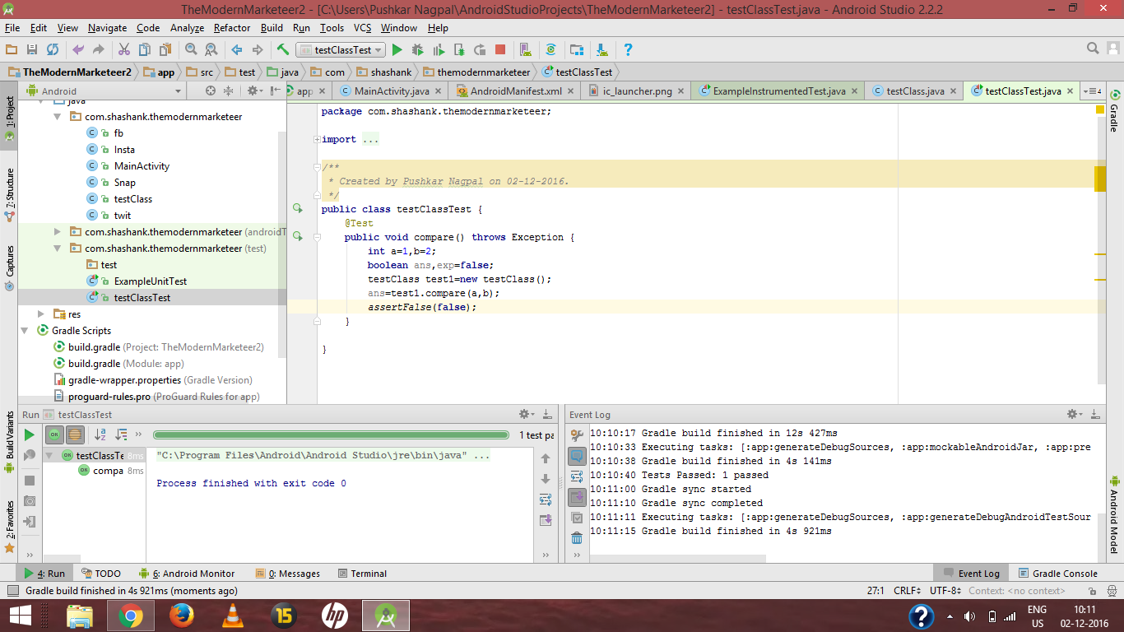

This screenshot shows one of the test-case for the application and every Java class has been tested for in this application.

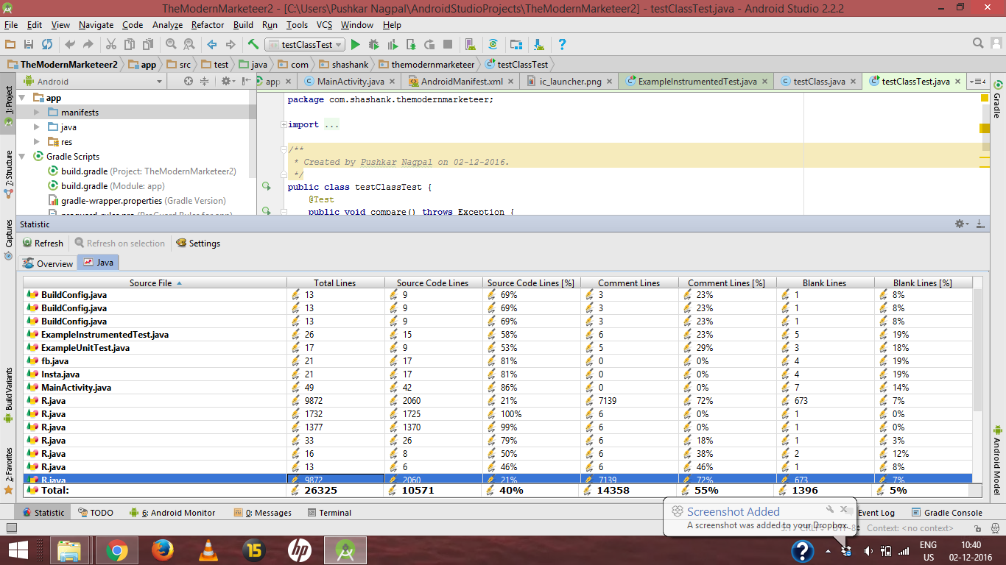

Each function was tested for and test case generated

A dependency ‘junit:4.12’ was used for the test case functionality to develop the application.